**EVENT MANAGEMENT**

BY TEAM 14

VANSHIKA JOLLY

AVINASH BHOJWANI

RADHIKA CHHABRA

SREENIVASAPUR ADNAN RAQEEB

## Description :

The main objective of the Project on Event Management System is to manage the details of Event, Activity, Organizers, Attendees, Payments, and Conductors. The project is totally built at administrative end and thus only the administrator is guaranteed the access. The purpose of the project is to build an application program to reduce the manual work for managing the Event, Activity, Payment, Organizers.

The aim is to automate its existing manual system by the help of computerized equipment and full-fledged computer software, fulfilling their requirements, so that their valuable data/information can be stored for a longer period with easy accessing and manipulation of the same. Basically the project describes how to manage for good performance and better services for the clients.

## Problem statement :

Event Management System, as described above, can lead to error free, secure, reliable and fast management system. It can assist the user to concentrate on their other activities rather to concentrate on the record keeping. Thus it will help organization in better utilization of resources. The organization can maintain computerized records without redundant entries. That means that one need not be distracted by information that is not relevant, while being able to reach the information.

The main objective of this application is to develop a system that effectively manages all the data related to the various events that take place in an organization. The purpose is to maintain a centralized database of all event related information.

It may help collecting perfect management in details. In a very short time, the collection will be obvious, simple and sensible. It will help a person to know the management of passed year perfectly and vividly. It also helps in current all works relative to Event Management System. It will be also reduced the cost of collecting the management & collection procedure will go on smoothly.

Our project aims at Business process automation, i.e. we have tried to computerize various processes of Event Management System.

**Functionalities provided by Event Management System are as follows:**

**\*** Options forEditing, adding and updating of Records is available to both customer and admin which results in proper Resource management of Event data.

**\*** We provide login to the customer and admin through their user id and password. Admins are already provided with their user id and password while for customers if he is a new user he can easily register and get their login credentials by providing some basic details and in future he can login using those credentials.

**\*** we are asking the customer to select the date and type of event and the city in which he wants to book the event. We are storing these information securely in our database.

**\*** After login a customer is asked to select the 5 fundamentals(venue, catering ,music , photography )needed to conduct an event.

**\*** Provides the searching facilities based on various factors. The customer can select different thing according to their requirements.

**\*** After all the bookings we provide the details of all the things selected by the customer and the final price of the booking item is shown to the customer.

**\*** We provide some of the basic methods for the Payments(debit card , upi , wallet transfer) of the bookings of customer.

* After all the bookings are done and the payment is confirmed we will send customer the email for the confirmation of bookings of the customer.

**\*** Provides the searching facilities based on various factors. The customer can select different.

**\***To increase efficiency of managing the events.

METHODOLOGY**:**

This project supports two types of users

* ADMIN
* CUSTOMER

Each user will have their own set of functionalities and both have common feature of login. Admin login Credentials already defined and stored so the admin can’t register, whereas the Customer can register and access through our application.

After successful login of Admin, they will be processed to the **Dashboard** which gives admin his two options which are to make changes in Inventory or check on the registered customers and their bookings.

If admin choose to make changes in inventory he will be given options with our 5 major constraints of event In **UpdateInventory class**

VENUE  
CATERING  
MUSIC  
PHOTOGRAPHY  
DECORATION

And after selecting any they will be given with options of **view, add, alter, delete** by passing control to UpdateInventory Class methods which have been implemented for each Constraint and choosing one of them will be invoking the method with the same respective name and then to either extract or enter data to our resource holding data base and they will be present in the Gateway class except for venue Constraint which will be invoking VenueGateway rather than Gateway because it has few additional field which are capacity etc. and after adding or deleting or altering they will be processed back and later if they choose to go back it control would have flown to Dashboard again with invoking the object.

Now If the admin choose to access the registered customer files then he will be given the options of either accessing their credentials ,i.e. registered customer username,email,phone number etc. or either access the booking orders of customers or to check the payment status of the booking order .for all these the class **CustomerDetails** will be used with proper implemented methods and after accessing any of them the control will be in display method of this class to ask again if he needs access others or go back.

Go back will be move us to Dashboard and again going back we will be logged out and move to initial login page

A new customer have to register with some of the basic details and next time if the customer want to visit our system he don’t have to register he can directly login as his registered details are stored.

Firstly , we have dashboard which stores date, place, no. Of people given by the customer and those will be inherit further. Now input class will take input from customers i.e. date ,place number of guests. Detail class is an abstract class which is inherited from dashboard.

Detail class is a super class for 5 further classes which are venue, catering, photography, music ,decoration. These have some common abstract methods getOptions() , getDetails() , ask(), getID().

getOptions- it will show the option to the customer according to their requirements.

getDetails- it will show the details of what user want to see.

getID- it will return the booked ID of 5 classes.

ask- it will ask whether the customer want to book or view.

We have categorize all the fundamental things required for event . We have not made this for a particular section of society but we keep in mind every type of people in a society either they are rich or they are medium class so they can choose anything according to their requirements .

Now, firstly we will ask the customer for the requirements by ask method . Then we will show all the options available as per the requirements by getOptions method. Customer can view the details of each option shown by getDetails method and finally book whatever they want by book method. There is also a method back to go back if the customer want to change anything. If the venue is booked on a particular date and on your city then you can’t book that one , you have to change your choice Same goes with catering, decoration, music and photography .Once booking is done we will provide booking id to access the booking in future.

After booking we will provide various payments method to customer like debit card , gpay, phonpe and even pay later if customer wants to do so. Once payment is done and is received by admin the an email will be sent to the customer showing all the booking details.

Requirements:

* MySQL Jar connector
* Email jar connector
* JDK version of 8 and above.
* Dump files of the table to connect in Mysql

## RESULTS:

-----------Screenshot of registering a new customer--------------

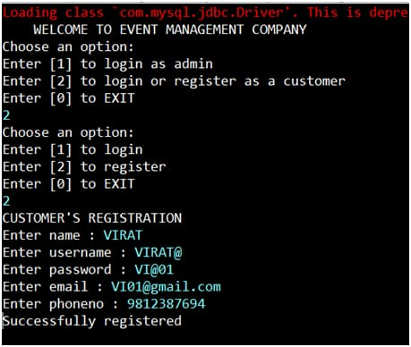

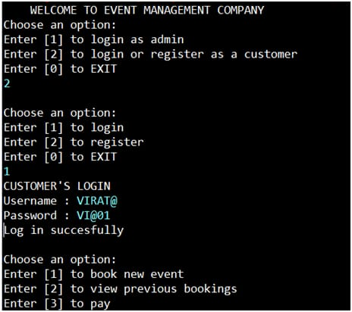 --------------Logging in with the registered credentials--------------

-----------Screenshot showing the Venue has already been booked --------------

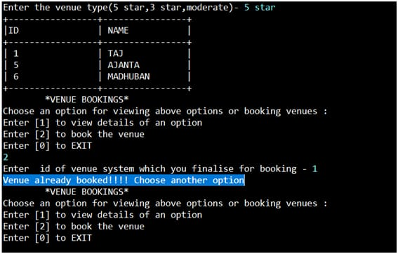

Class Diagram for Package Customer

